1.质量标准Quality Standard

| 序号  No | 项目  Item | 接受标准  Acceptance Criteria | 检测器具和设备  Test Apparatus and Equipment | 检测方法  Test Method | 严重度  Severity | 抽样方案  Sample Plan |
| --- | --- | --- | --- | --- | --- | --- |
| 1 | 外观 | 表面无划痕、擦伤等缺陷；无毛刺飞边；干净无污渍 | / | 正常或矫正视力目视 | B | 采用GB/T2828.1-2012抽样方案或自定义 |
| 2 | 尺寸 | 见附图 | 三坐标测量仪或游标卡尺等 | 根据尺寸特点及量具选择定义检测方法 | B | 采用GB/T2828.1-2012抽样方案或自定义 |

2. 单证资料Certification Document:

无。

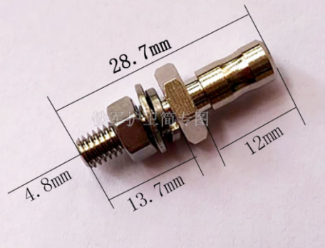

3.图纸号Drawing No. :

无。

4.批的定义Lot Definition :

生产批：在一段时间内，同一生产工艺条件下连续神产出的具有同一性质和质量的产品确定的数量。

[production](javascript:;) Lot: A defined quantity of a product with the same performance and quality produced continuously over a period of time under the same process conditions.

5.生产场地和环境要求Manufacture Place and Environment Requirements:

无。

6.包装&运输要求Packaging &Shipping Requirements:

普通物料：

供应商应提供合适的包装防护措施，确保产品在运输过程中不发生损坏；在包装外部可见的地方应粘贴标签，显示货物名称、批号、数量等信息。

For ordinary materials: The supplier shall provide suitable package to ensure that the product is not damaged during transportation; a label shall be affixed visibly on the outside of the package to display the name, batch number, quantity etc...

洁净物料：

供应商应提供合适的包装防护措施，确保产品在运输过程中不发生损坏；在包装外部可见的地方应粘贴标签，显示货物名称、批号、数量等信息；内层包装采用双层密封包装（于净化车间完成）；外层包装采用的包装用料不得在运输存贮过程中影响产品质量；运输过程中包装应防潮、防晒、防雨淋；防破损、防变形、防污染。

The supplier shall provide appropriate packaging protection measures to ensure that the product is not damaged during transportation; labels should be affixed visibly outside the package, showing information such as name, lot number, quantity, etc. The inner packaging shall be packed with double sealed package (completed in the purification workshop); the outer packaging materials shall not affect the quality of the product during transportation and storage; the packaging shall be moisture-proof, sun-proof, and rain-proof during the transportation process and can prevent damage, deformation, and pollution.

7.售后服务After Service:

当有重要原材料变化、设计变更或产品有严重质量问题时通知上海神玑医疗科技有限公司。

Shanghai ShenJi Medical Technology Corporation Limited is notificated when there are important changes in raw materials, design changes or serious quality problems of products.

8.备注Remark:

无。

9.签字 Signature:

|  |  |  |  |  |  |  |  |
| --- | --- | --- | --- | --- | --- | --- | --- |
| 编制人Compiled by |  | 标准化Controlled by |  | 质量工程师或质量经理审核  Review by QA Engineer or QA Manager |  | 项目经理批准  Approved by PM |  |
| 日 期Date |  | 日 期Date |  | 日 期  Date |  | 日 期  Date |  |

10.供方确认Confirmed by Supplier:

|  |  |  |  |
| --- | --- | --- | --- |
| 供应商名称  Supplier name | 部门  Department | 职务  Duty | 确认人/确认日期  Confirmed by/Date |
|  |  |  |  |

11.文件变更历史Version History:

**文件变更历史**

|  |  |  |  |
| --- | --- | --- | --- |
| 版本  Version | 编写日期  Compiled Date | 编制人  [Editor](javascript:;) | 变更内容  Change content |
| A | 2022-02-14 | 王德倡 | 建立新文件。 |
| B | 2022-11-17 | 王德倡 | 删除材料检查项，外观与尺寸抽样方案由全检改为采用GB/T2828.1-2012抽样方案或自定义。 |